INFS 346 HW 10, Eric Diaz

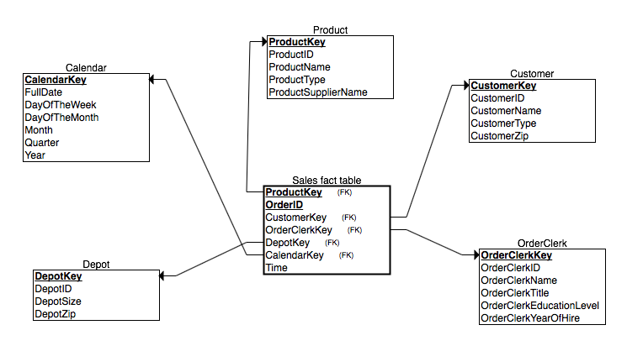

***Product***

|  |  |  |  |  |
| --- | --- | --- | --- | --- |
| **ProductKey** | ProductID | ProductName | ProductType | ProductSupplierName |
| 1 | P1 | BigGripper | Tire | Super Tires |
| 2 | P2 | TractionWiz | Tire | Super Tires |
| 3 | P3 | SureStart | Battery | Batteries Etc |

***Customer***

|  |  |  |  |  |
| --- | --- | --- | --- | --- |
| **CustomerKey** | CustomerID | CustomerName | CustomerType | CustomerZip |
| 1 | C1 | Auto Doc | Repair Shop | 60137 |
| 2 | C2 | Bo’s Car Repair | Repair Shop | 60140 |
| 3 | C3 | JJ Auto Parts | Retailer | 60605 |

***OrderClerk***

|  |  |  |  |  |  |
| --- | --- | --- | --- | --- | --- |
| ***OrderClerkKey*** | OrderClerkID | OCName | OCTitle | OCEducationLevel | OCYearOfHire |
| 1 | OC1 | Antonio | Order Clerk | High School | 2001 |
| 2 | OC2 | Wesley | Order Clerk | College | 2005 |
| 3 | OC3 | Lilly | Order Clerk | College | 2005 |

***Depot***

|  |  |  |  |
| --- | --- | --- | --- |
| **DepotKey** | DepotID | DepartmentSize | DepartmentZip |
| 1 | D1 | Small | 60611 |
| 2 | D2 | Large | 60660 |
| 3 | D3 | Large | 60611 |

***Calendar***

|  |  |  |  |  |  |  |
| --- | --- | --- | --- | --- | --- | --- |
| **CalendarKey** | FullDate | DayofWeek | DayofMonth | Month | Quarter | Year |
| 1 | 1-Jan-2013 | Tuesday | 1 | 1 | 1 | 2017 |
| 2 | 2-Jan-2013 | Wednesday | 2 | 1 | 1 | 2017 |
| 3 | 3-Jan-2013 | Thursday | 3 | 1 | 1 | 2017 |

***Sales fact table***

|  |  |  |  |  |  |  |
| --- | --- | --- | --- | --- | --- | --- |
| **ProductKey** | **OrderID** | CustomerKey | OCKey | DepotKey | CalendarKey | Time |
| 1 | O1 | 1 | 1 | 1 | 1 | 9:00:00 AM |
| 2 | O1 | 1 | 1 | 1 | 1 | 9:00:00 AM |
| 1 | O2 | 2 | 2 | 2 | 2 | 9:00:00 AM |
| 2 | O3 | 3 | 3 | 3 | 3 | 9:30:00 AM |
| 3 | O4 | 1 | 1 | 1 | 1 | 9:00:00 AM |
| 3 | O5 | 2 | 2 | 2 | 2 | 9:15:00 AM |
| 2 | O6 | 3 | 3 | 3 | 3 | 9:30:00 AM |
| 1 | O6 | 3 | 3 | 3 | 3 | 9:30:00 AM |